Project Strategy and Outcomes Worksheet
Partnership or Project Name:

Please complete and submit this worksheet with your proposal. For guidance on completing the worksheet, please see Appendix A.

Theory of Change
You may use the chart below to demonstrate your Theory of Change, or you may submit your own. If using our template, feel free to add columns or delete columns. You do not need to include detailed information in the chart, as this can be provided later in the worksheet or in the grant narrative.

Need: Brief statement of need you are addressing
Application Category: ____Innovating ____Scaling ____Sustaining
Goal: What is your long-term, transformative goal? |  |  | Lever: What lever(s) for change do you propose to address?  ☐Compensation  ☐Working Conditions  ☐Targeted Recruitment  ☐Career and Education Pathways
Strategy: What strategy are you proposing for this grant that could impact your transformative goal?
Activities | Outputs | Short-term Outcomes | Intermediate Outcomes | Long-Term Outcomes | Transformative Goal | Initiative’s Goal
 |  |  |  |  |  | Increased recruitment, retention, and compensation of an effective, qualified workforce.

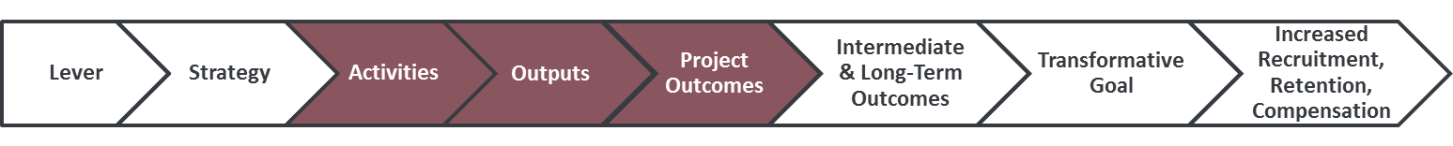

Project Activities, Outputs, and Outcomes
Please list the project activities, outputs, and outcomes and how you will measure progress or success of each. Please identify which outcomes will happen during the course of the project/grant term, at the end of the grant term, or in the future after the grant term is completed.

Activities:
Project Activities | Date to be completed
Example: Develop an action plan to increase stakeholder support for public funding to increase compensation | July 2020

Outputs: Please note, different types of indicators — process, quantity, and/or quality—may be more appropriate to measure outputs for different projects.
Process Outputs | Date to be completed | Target Benchmark
Example: Action plan to develop concurrent enrollment program completed | June 2021 | Target benchmarks are not needed for process metrics.
Quantity Outputs | Date to be completed | Target Benchmark
Example: # of modules or courses developed | September 2021 | 3 modules or courses developed
Example: # of courses pilot tested | December 2021 | 3 courses pilot tested
Quality Outputs | Date to be completed | Target Benchmark
Example: Students are satisfied with the piloted modules or courses | December 2021 | 90% of students report satisfaction with the piloted modules
Example: Students are progressing on track for completion of modules with a 3.2 average | May 2022 | 80% of students have a 3.2 GPA average or higher in the piloted course or modules

Project/Grant Outcomes: (During or at the Conclusion of the Grant Term)
Year 1 Outcomes
Example: % students employed with a partner early education program | December 2021 | 90% of students are employed with a partner early education program

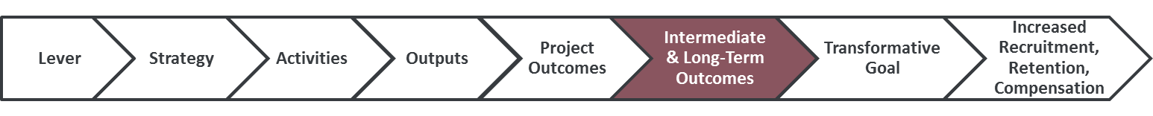
Intermediate and Long-Term Outcomes
Future Outcomes- After the One-Year Grant Term
Example: % students employed for 1 year with a partner early education program | December 2021 | 85% of students remain employed with a partner early education program for 1 year
Example: % students employed for 2 years with a partner early education program | December 2023 | 75% of students remain employed with a partner early education program for 2 years

